Michael Klein, 27 February 2012

New feature in PELMO

Metabolites formed by soil photolysis

Table of Content

Information on the new option 2
Example simulations using the new option 5
Example 1: 5
Example 2: 7
Example 3: 9
References 11

Information on the new option

In the current version of PELMO the degradation of parent compounds by soil photolysis can be calculated as described in the PELMO 4 user manual (Klein 2011). The fraction degraded by soil photolysis was added to the sink/bound residues compartment. The calculation of the formation of metabolites by soil photolysis was so far not possible.
In the new version the formation of up to 4 metabolites formed by soil photolysis can be calculated using PELMO. In the new metabolites scheme the formation by photolysis and by biodegradation can be combined (see the following figure).

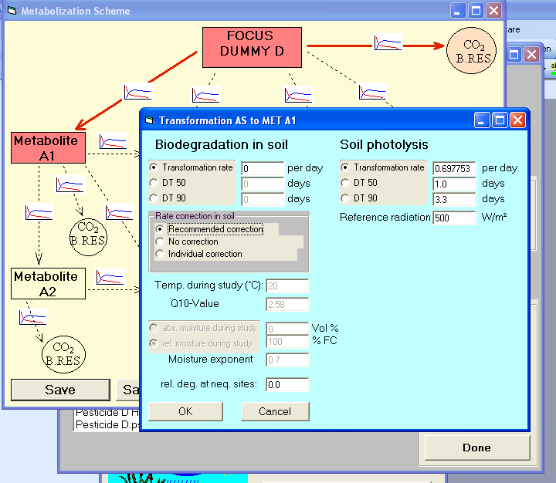
Figure 1: Formation of metabolites by biodegradation and/or soil photolysis of the parent

As in the previous version the degradation of the parent compound can be expressed either by the rate constant or by the DT50. The reference radiation is used to adapt the transformation to the actual weather conditions.
It is still possible to consider the degradation of parent compounds without forming metabolites (same calculation as in the current official FOCUS PELMO version). However, for transparency reasons the respective parameters input was shifted from the parent form to the metabolism scheme (Parent’s degradation to CO2/bound residues) and the respective input fields on the parent input sheet have been removed.

In order to document the new routines PELMO’s standard output file “echo.plm” was extended by adding the new input parameters (see the following table):

SOIL PHOTOLYSIS OF ACTIVE SUBSTANCE
-----------------------------------
METABOLITE FORMED MET. A1 MET. B1 MET. C1 MET. D1 BR/CO2
--------------------------------------------------------------------------------
REFERENCE RADIATION [W/M2] 500.0 500.0 500.0 250.0 500.0
REFERENCE PHOTOLYSIS RATE [1/D] 0.6978 0.0000 0.0000 0.0000 0.0000
Table 1: Extensions in the file Echo.plm to cover the formation of metabolites by photolysis

As it may be interesting to analyse the daily formation of metabolites by photolysis (but also by biodegradation) the standard daily diagrams provided by PELMO now also cover the formation of metabolites.

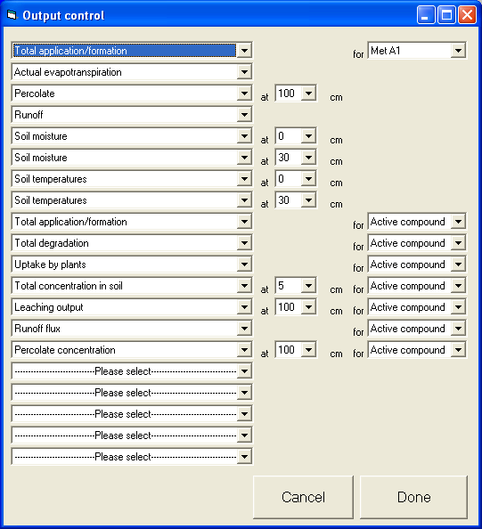
Figure 2: Selecting information on formation of metabolites (before the simulation)

After the simulation the formation can be visualised using the standard form which appears when the button “EVALUATION” was pressed.

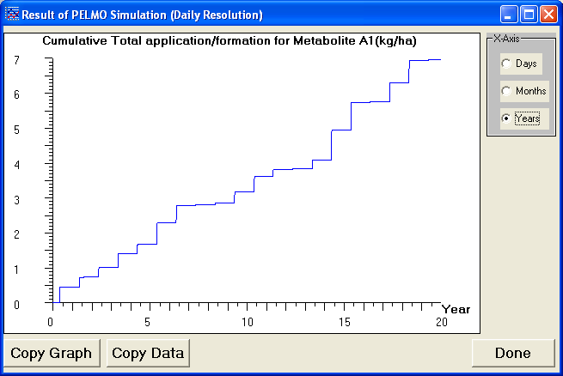
Figure 3: Analysing the formation of metabolites (after the simulation)
Metabolites which are formed by soil photolysis are an integrated part of the metabolism scheme and can be further degraded or transformed to other compounds.
Once they are present in the soil PELMO does not distinguish whether they were originally formed by soil photolysis or biodegradation in soil.

Example simulations using the new option

Example 1:

Input parameters
Parent: FOCUS D
Moleculare mass: 300 g/mol
KOC: 60 L/kg
DT50soilmatrix: 20 d at 20 °C and pF 2, Q10: 2.58 (to CO2/Bound residues)
DT50photolysis 1 d at 500 W/m²
Vapour pressure: 1 10⁻⁴ Pa at 20 °C
Water solubility: 90 mg/L at 20 °C
Plant uptake factor: 0.5

Metabolite A
Formation: Only formed by soil photolysis
Moleculare mass: 300 g/mol
KOC: 60 L/kg
DT50soilmatrix: 60 d at 20 °C and pF 2, Q10: 2.58
DT50photolysis not possible
Vapour pressure: 0
Plant uptake factor: 0.5

Application pattern

Application rate: 1 kg/ha
Application date: 1 day before crop emergence
Application mode: annual
Target crop: maize

FOCUS Scenario: FOCUS Hamburg

Results
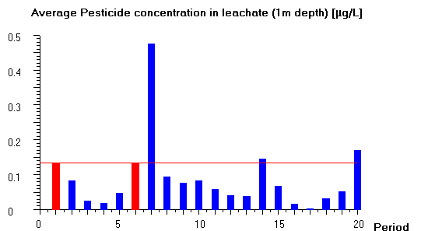
Figure 4: Example 1: Pesticide concentration in the leachate (scenario: FOCUS Hamburg)
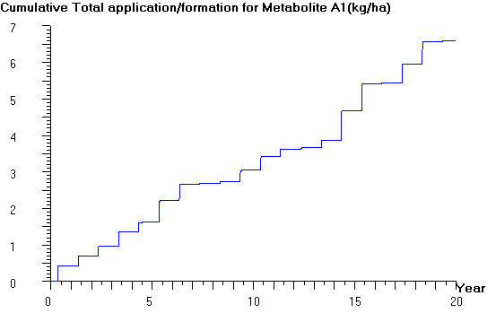
Figure 5: Example 1: Formationof the metabolite (scenario: FOCUS Hamburg)
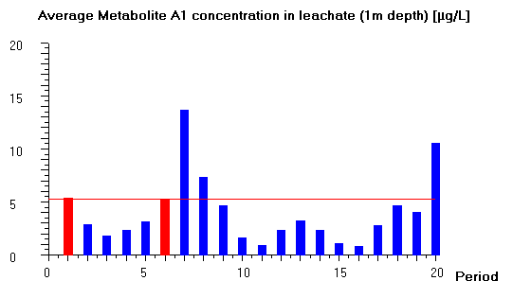
Figure 6: Example 1: Metabolite concentration in the leachate (FOCUS Hamburg)

Example 2:

Input parameters
Parent: FOCUS D
Moleculare mass: 300 g/mol
KOC: 60 L/kg
DT50soilmatrix: 20 d at 20 °C and pF 2, Q10: 2.58 (to Metabolite A)
DT50photolysis 1 d at 500 W/m²
Vapour pressure: 1 10⁻⁴ Pa at 20 °C
Water solubility: 90 mg/L at 20 °C
Plant uptake factor: 0.5

Metabolite A
Formation: formed by soil photolysis and degradation in soil
Formation fraction: 100 %
Moleculare mass: 300 g/mol
KOC: 60 L/kg
DT50soilmatrix: 60 d at 20 °C and pF 2, Q10: 2.58
DT50photolysis not possible
Vapour pressure: 0
Plant uptake factor: 0.5

Application pattern

Application rate: 1 kg/ha
Application date: 1 day before crop emergence
Application mode: annual
Target crop: maize

FOCUS Scenario: FOCUS Hamburg

Results
Figure 7: Example 2: Pesticide concentration in the leachate (scenario: FOCUS Hamburg)
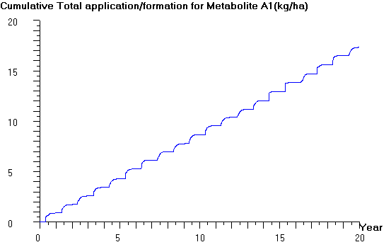
Figure 8: Example 2: Formationof the metabolite (scenario: FOCUS Hamburg)
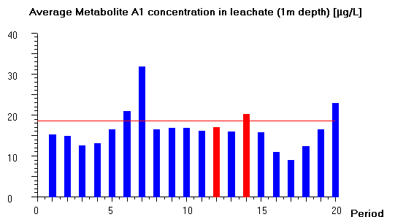
Figure 9: Example 2: Metabolite concentration in the leachate (FOCUS Hamburg)

Example 3:

Input parameters
Parent: FOCUS D
Moleculare mass: 300 g/mol
KOC: 60 L/kg
DT50soilmatrix: 20 d at 20 °C and pF 2, Q10: 2.58 (to both metatbolites)
DT50photolysis 1 d at 500 W/m²
Vapour pressure: 1 10⁻⁴ Pa at 20 °C
Water solubility: 90 mg/L at 20 °C
Plant uptake factor: 0.5

Metabolite A
Formation: formed by soil photolysis and degradation in soil
Formation fraction: 50 % from parent compound
Moleculare mass: 300 g/mol
KOC: 60 L/kg
DT50soilmatrix: 60 d at 20 °C and pF 2, Q10: 2.58
DT50photolysis not possible
Vapour pressure: 0
Plant uptake factor: 0.5

Metabolite B
Formation: formed by soil photolysis and degradation in soil
Formation fraction: 50 % from parent compound
Formation fraction: 100 % from metabolite B
Moleculare mass: 300 g/mol
KOC: 60 L/kg
DT50soilmatrix: 60 d at 20 °C and pF 2, Q10: 2.58
DT50photolysis not possible
Vapour pressure: 0
Plant uptake factor: 0.5

Application pattern

Application rate: 1 kg/ha
Application date: 1 day before crop emergence
Application mode: annual
Target crop: maize

FOCUS Scenario: FOCUS Hamburg

Results
Figure 10: Example 3: Pesticide concentration in the leachate (scenario: FOCUS Hamburg)
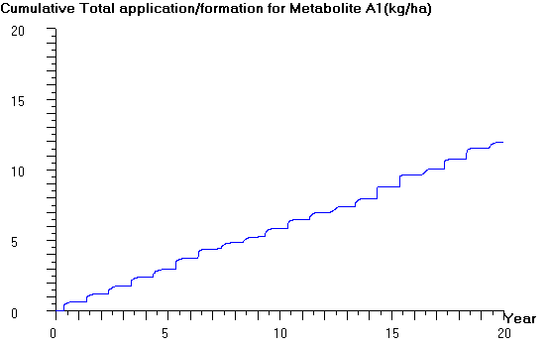
Figure 11: Example 3: Formationof metabolite A (scenario: FOCUS Hamburg)
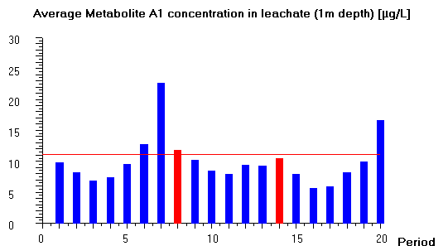
Figure 12: Metabolite A concentration in the leachate (FOCUS Hamburg)

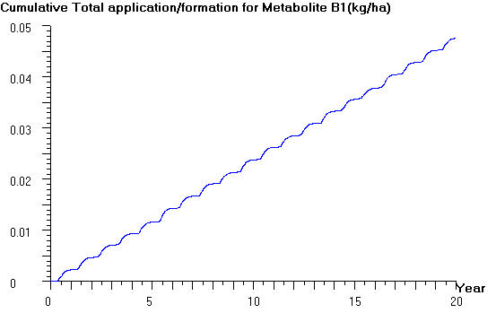
Figure 13: Example 3: Formationof metabolite B (scenario: FOCUS Hamburg)

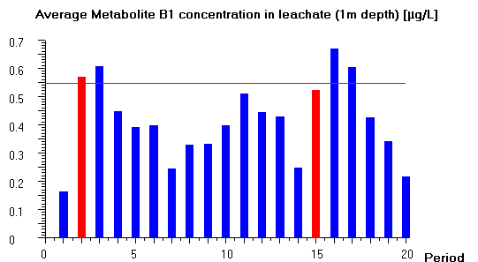
Figure 14: Example 3: Metabolite B concentration in the leachate (FOCUS Hamburg)

References

Klein (2011): PELMO (Pesticide Leaching Model) Version 4.0 User manual Fraunhofer IME, Schmallenberg

