**Study Report**

Predicted Environmental Concentrations in Soil of Cyanamide, Calcium cyanamide, Urea and Dicyandiamide after fertilization with PERLKA® using ESCAPE 2.0

*Simulations in Potatoes*

**Sponsor**

AlzChem Trostberg GmbH

Dr.-Albert-Frank-Str. 32

83308 Trostberg

Germany

**Institute**

Fraunhofer Institute for Molecular  
 Biology and Applied Ecology IME  
 Auf dem Aberg 1

57392 Schmallenberg  
 Germany

**Head of Applied Ecology**

Prof. Dr. Christoph Schäfers

**Author**

Dr. Michael Klein

Dr. Judith Klein

November 20, 2019

This page was intentionally left blank for statements of the sponsor or submitter.

Statement of compliance

This study “*Predicted Environmental Concentrations in Soil of Cyanamide, Calcium cyanamide, Urea and Dicyandiamide after fertilization with PERLKA® using ESCAPE 2.0- Simulations in Potatoes*” was conducted according to the procedures described herein. This report is a true and accurate record of the results obtained. There were no circumstances that may have adversely impacted the quality or integrity of the study.

The GLP-regulation is not applicable. However, the study was performed in accordance with the Codex of “Good Modelling Practices” (Görlitz 1993 und Travis 1995).

______________________________________ __November 20, 2019______

Dr. Michael Klein Date

Exposure modelling

Fraunhofer Institute IME

Auf dem Aberg 1

57392 Schmallenberg

Tel +49 2972 302 317

Fax +49 2972 302 319

michael.klein@ime.fraunhofer.de

**Contents page**

Statement of compliance 3

1. Simulation model 5

2. Scenarios 6

Soil and climate scenarios of the simulation models 6

3. Physico-chemical and Degradation Data 7

PERLKA® 7

Cyanamide 7

Urea 8

Dicyandiamide 8

4. Results 11

5. Conclusion 13

6. References 14

7. Appendix: Detailt result of the simulations produced by the model 15

# Simulation model

ESCAPE (Estimation of Soil Concentration After PEsticide applications) was developed in 2008 to calculate actual as well as time weighted average concentrations in soil for the parent compound and additional metabolites (Klein 2008). In addition to SFO kinetics (single first order) the software is able to consider hockey stick – kinetics (HS), FOMC- kinetics (first order multi compartment) and DFOP- kinetics (double first order in parallel). ESCAPE can handle singular and multiple applications over a simulation period of 10 years. It also considers different soil depths and performs corrections of actual rates dependent on the current crop interception automatically. Visualisation of results is carried out graphically (diagram showing the simulated concentrations vs. time) and tabularly based on time intervals as defined by EU or national regulations. Degradation rates can be corrected based on actual soil moisture and temperature data. Finally, realistic worst case scenarios based on specific information on soil cores and climate data sets containing daily weather series can be used for the calculations. The computer model is used mostly for national registration of plant protection products in the EU.

ESCAPE can only describe three transformation schemes and up to two metabolites: 1) a parent with one metabolite, 2) a parent with two sequential metabolites and 3) a parent with two parallel metabolites.

In order to consider the all substances the calculation in ESCAPE was done in a stepwise approach:

Run 1) PERLKA® → cyanamide →urea

Run 2) PERLKA® → cyanamide → dicyanadiamide.

# Scenarios

## Soil and climate scenarios of the simulation models

For the simulation only a single scenario was considered.

* Climate: Constant temperature of 12 °C
* Soil: Soil with a soil bulk density of 1.5 kg/L
* Agricultural practice: Regular tillage over 20 cm (1 time per year)
* Crop: Specific crops cannot be defined in ESCAPE 2.0
* Simulation period: 10 years of annual applications

# Physico-chemical and Degradation Data

## PERLKA®

The maximum concentration of calcium cyanamide in PERLKA® is about 45%. In order to adequately simulate the slow release of cyanamide from PERLKA® granules to soil, cyanamide was defined as a metabolite. According to experimental data the half-life of PERLKA® (CaCN2) in soil was found to be between 0.60 days and 1.80 days. The experimental values were normalised to 20 °C using a Q10 factor of 2.2 as recommended by FOCUS (2000). The experimental half-lives were also normalised to pF 2 (field capacity, see appendix A) using an exponent of 0.7 as the model requires degradation at optimised moisture conditions. Also the moisture correction was done according to FOCUS (2000). The geometric mean of all normalised half-lives was found to be 0.721 days. This value was considered for the modelling.

PERLKA® granules cannot be dissolved in water without being transformed to cyanamide. In order to simulate the fate of PERLKA® realistically the sorption constant in soil KOC was set to an artificial, high number (172400 L/kg). This should guarantee that within the model the granules remain at the applied location in soil and are only transformed to cyanamide without leaching to deeper soil layers. This can be considered a worst case selection of the formation of cyanamide.

## Cyanamide

According to experimental data cyanamide is further transformed to urea. Also for cyanamide the experimental half-lives were normalised to 20 °C using a Q10-Factor of 2.2 as given by FOCUS (2000). However, for cyanamide no soil moisture normalisation was done since according to the experimental results the degradation of cyanamide does not increase with soil moisture (Klein 2019). Consequently, the soil moisture correction in the model FOCUS PEARL model is not suitable and the moisture correction was switched off. For the modelling a half-life of 0.78 days was used. The value represents the geometric mean of all experimental data after normalisation to 20 °C but without soil moisture normalisation (see Klein 2019).

For cyanamide an average (geometric mean) sorption constant of 4 L/kg was considered which was based on experimental sorption studies (EFSA 2010).

Cyanamide has a Henry’s law constant of 2.68 10-5 J/mol. However this value cannot be entered directly into FOCUS PEARL but will be internally calculated based on water solubility, vapour pressure and molecular mass.

Plant uptake was not considered since the granules are usually applied before emergence of the crop.

## Urea

According to experimental data cyanamide is further transformed to urea (Vilsmeier et Amberger 1978). The formation fraction from cyanamide to urea was set to 95.7 %.

For the half-life of urea 3.9 days at 20°C was taken. This is the geometric mean given in EFSA (2010). The computer automatically transfers the half lives at standard temperatures into the actual conditions of the scenarios. The sorption constant in soil KOC was set to 7.2 L/kg which was calculated from Hongprayoon (1991). The taken KOC value for urea corresponds to the mean of KOC values ranging from 5.3 to 9.1.

Plant uptake was not considered since the granules are usually applied before emergence of the crop.

## Dicyandiamide

In addition, cyanamide is also transformed to dicyandiamide. The formation fraction from cyanamide to dicyandiamide was set to 4.25 %. For dicyandiamide a half-life of 11.1 days at 20°C was considered. The sorption constant in soil KOC was set to 5.25 L/kg (registration dossier).

Calcium cyanamide

Molecular Mass: 80.11 g/mol

Adsorption 172400 L/kg (Koc) (artificial, to reflect immobility of granulated PERLKA®)   
*Please notice the Koc has no influence in ESCAPE as long as not porewater concentrations are calculated.*

Degradation: DT50: 0.721 d at 20 °C

Temperature correction:

Reference temperature T0: 20 °C (FOCUS, 2000)

Q10-factor: 2.2 (FOCUS, 2000)

Moisture correction:

Moisture exponent: 0.7 (FOCUS, 2000)

Reference soil moisture: 100 % FC

Application date: 1 May

Application mode: annual application

Application rate: Scenario: 135 kg CaCN2 (= 300 kg PERLKA®/ha) in potatoes incorporated over 15 cm

Cyanamide

Molecular Mass: 42.04 g/mol

Adsorption 4 L/kg (Koc)   
*Please notice the Koc has no influence in ESCAPE as long as not porewater concentrations are calculated.*

Degradation: DT50: 0.78 d at 20 °C

Temperature correction:

Reference temperature T0: 20 °C (FOCUS, 2000)

Q10-factor: 2.2 (FOCUS, 2000)

Moisture correction:

Moisture exponent: 0 (no correction)

Reference soil moisture: not applicable

Formation fraction: 100%

Urea

Molecular Mass: 60.06 g/mol

Adsorption Koc, Mean=7.2 L/kg  
Calculated from Hongprayoon C et al 1991 *Please notice the Koc has no influence in ESCAPE as long as not porewater concentrations are calculated.*

Degradation: DT50: 3.9 d at 20 °C (EFSA 2010)

Reference temperature T0: 20 °C (FOCUS, 2000)

Q10-factor: 2.2 (FOCUS, 2000)

Moisture correction:

Moisture exponent: 0.7 (FOCUS, 2000)

Reference soil moisture: 100 % FC

Formation fraction: 95.7%

Dicyandiamide

Molecular Mass: 42.04 g/mol*

Adsorption 5.25 L/kg (Koc),Registration dossier   
*Please notice the Koc has no influence in ESCAPE as long as not porewater concentrations are calculated.*

Degradation: DT50: 11.1 d at 20 °C

Reference temperature T0: 20 °C (FOCUS, 2000)

Activation energy: 54 kJ mol-1 (FOCUS, 2009)

Moisture correction:

Moisture exponent: 0.7 (FOCUS, 2000)

Reference soil moisture: 100 % FC

Formation fraction: 4.25%

* ESCAPE is not able to directly simulate dimerization (which laeds to a reduction of the number of molecules to 50%). In order to calculate the correct mass balance only 50% of the molecular mass of DCD was considered, but the number of molecules was kept constant.

# Results

The global maximum concentrations are summarised in the following tables. The application of 300 kg PERLKA®/ha in potatoes incorporated over 15 cm was considered.

The absolute maximum concentration was calculated for the parent calcium cyanamide (PECmax 60 mg/kg). For the metabolite cyanamide the highest concentrations was calculated to be 15.4179 mg/kg. For the two secondary compounds urea and DCD maximum concentrations of 22.4707 mg/kg and 0.9449 mg/kg were calculated, respectively.

The time weighted average concentrations over 21 days are significantly below the maximum values, especially for CaCN2 (5.7056 mg/kg) and Cyanamide (3.9774 mg/kg). The respective results for urea and DCD were 11.9042 mg/kg and 0.7126 mg/kg, respectively.

Table 1: Results of PECsoil simulations using ESCAPE 2.0 for PERLKA®, cyanamide, urea and dicyandiamide

|  |  |  |  |  |
| --- | --- | --- | --- | --- |
| Scenario | Potatoes, 300 kg/ha incorporated over 15 cm | | | |
|  | Calcium cyanamide (PERLKA®) | Cyanamide | Urea | Dicyandiamide |
| mg/kg | mg/kg | mg/kg | mg/kg |
| PEC max | 60.0000 | 15.4179 | 22.4707 | 0.9449 |
| TWA 1 d | 47.9856 | 14.7792 | 22.3077 | 0.9421 |
| TWA 2 d | 38.377 | 14.3965 | 22.1258 | 0.9391 |
| TWA 4 d | 26.0853 | 12.9498 | 21.4572 | 0.9273 |
| TWA 7 d | 16.6407 | 10.1841 | 20.0219 | 0.9013 |
| TWA 14 d | 8.552 | 5.9181 | 15.7118 | 0.8127 |
| TWA 21 d | 5.7056 | 3.9774 | 11.9042 | 0.7126 |
| TWA 28 d | 4.2793 | 2.9842 | 9.2935 | 0.6208 |
| TWA 42 d | 2.8529 | 1.9895 | 6.2865 | 0.478 |
| TWA 50 d | 2.3964 | 1.6712 | 5.2859 | 0.4172 |
| TWA 100 d | 1.1982 | 0.8356 | 2.6438 | 0.2205 |

# Conclusion

Concentrations of calcium cyanamide, cyanamide, urea and dicyandiamide were calculated in the soil using the model ESCAPE which is normally used to calculate PECsoil for pesticides. As the model can only handle 2 metabolites two separate runs were performed to cover all substances. Annual applications of 300 kg/ha PERLKA incorporated over 15 cm into a potato field were simulated.

The absolute maximum concentration was calculated for the parent calcium cyanamide (PECmax 60 mg/kg). For the metabolite cyanamide the highest concentrations was calculated to be 15.4179 mg/kg. For the two secondary compounds urea and DCD maximum concentrations of 22.4707 mg/kg and 0.9449 mg/kg were calculated, respectively.

The time weighted average concentrations over 21 days are significantly below the maximum values, especially for CaCN2 (5.7056 mg/kg) and Cyanamide (3.9774 mg/kg). The respective results for urea and DCD were 11.9042 mg/kg and 0.7126 mg/kg, respectively.

# References

EFSA (2010): Conclusion on the peer review of the pesticide risk assessment of the active substance cyanamide. EFSA Journal 2010;8(11):1873.

FOCUS (2000). FOCUS groundwater scenarios in the EU plant protection product review process. Report of the FOCUS Groundwater Scenario Workgroup, EC Document Reference Sanco/321/2000.

FOCUS (2009): Technical advice on the Q10, agreed by the Commission Standing Committee on the Food Chain and Animal Health (provided by EFSA), available at FOCUS home page (http://viso.ei.jrc.it/focus/docs/Technical%20advice%20on%20the%20Q10.doc)

Görlitz G. (1993): Verfahrensregeln zur korrekten Durchführung und Auswertung von Modellrechnungen zur Simulation des Umweltverhaltens von Pflanzenschutzmitteln.

Klein, M. (2008): Calculation of PECsoil including Plateau Concentrations for Pesticides Dependent on FOCUS Degradation Kinetics. User Manual ESCAPE Version 2. Fraunhofer-Institut Molekularbiologie und Angewandte Ökologie 57392 Schmallenberg Available at <https://www.ime.fraunhofer.de/en/Media_Center/Calculation_models.html>

Klein, M. (2019): Moisture and Temperature correction of experimentally determined DT50 values for calcium cyanamide and cyanamide according to FOCUS. Report Fraunhofer IME, Schmallenberg.

Travis K.Z. (1995): Recommendations for the correct use of models and reporting of modelling results.- in: ‘Leaching Models and EU registration’. Final report of the FOCUS Group. Doc. 4952/VI/95

Vilsmeier, K.; Amberger, A. (1978): Modellversuche zum Umsatz von gemahlenen Kalkstickstoff und Perlkalkstickstoff in Abhängigkeit von Bodenfeuchtigkeit und Applikationsform. In: Z. Acker- und Pflanzenbau 147, S. 68–77.

Weinfurtner K. (2019): „Release and Transformation of Cyanamide from PERLKA®. Report Fraunhofer IME, Schmallenberg

# Appendix: Detailt result of the simulations produced by the model

***E S C A P E***

**Estimation of Soil Concentrations After PEsticide Applications**

*developed by Michael Klein*

Program version: 2.0 (21 September 2018)

Date of this simulation: 20/11/2019, 13:40:18

Calculation problem: Perlka mit Urea und 300 kg 15 cm

PROGRAM SETTINGS

Calculation mode: Residues from different applications are considered separately over one year

Application mode: Single annual application pattern (calculation period 1 year)

SCENARIO DATA USED IN THE CALCULATION

Name of the scenario: Perlka 300 kg pro ha oder 135 kg CaCN2

Name of the soil: Standard soil

Soil density (kg/L): 1.5

Soil depth (cm): 15

Tillage depth (cm)*: 20

Organic carbon content (%): 1.5

Field capacity (Vol%): 29.2

Wilting point (Vol%): 6.4

Climatic conditions: 12 °C constant

(* for calculation of background concentrations)

APPLICATION PATTERN USED IN THE CALCULATION

Crop rotation: every year

Application date: 1 May

Application rate (g/ha): 135000

Crop interception (%): 0

COMPOUNDS CONSIDERED IN THE CALCULATION

Metabolism scheme: Active compound and a sequence of two metabolites

Compound Molecular mass(g/mol) Formation (%)

Perlka 80.11

Cyanamid 42.04 4 100

Urea 60.06 7.2 95.7

DEGRADATION KINETICS PARAMETERS CONSIDERED FOR THE CALCULATION

Soil study: Most Recent Input Data

Metabolism scheme: Active compound and a sequence of two metabolites

Kinetics for Perlka: Single First order (SFO)

DT50 (d): 0.721

Rate constant (1/d): 0.9614

Q10-factor: 2.2

Walker-exponent: 0.7

Ref. temperature (°C): 20

Kinetics for Cyanamid: Single First order (SFO)

DT50 (d): 0.78

Rate constant (1/d): 0.8887

Q10-factor: 2.2

Walker-exponent: 0.0

Ref. temperature (°C): 20

Kinetics for Urea: Single First order (SFO)

DT50 (d): 3.9

Rate constant (1/d): 0.1777

Q10-factor: 2.2

Walker-exponent: 0.7

Ref. temperature (°C): 20

**RESULTS OF THE CALCULATION**

Metabolism scheme: Active compound and a sequence of two metabolites

***RESULTS FOR: Perlka***

Calculations over one year

Maximum annual total soil concentration for Perlka over 15 cm(mg/kg): 60.0000 occurring on day 0

Calculated time dependent total soil concentrations over 15 cm for Perlka after one year (mg/kg)

Time(d) PECact* PECtwa Begin TWAframe(d) End TWAframe(d)

1 35.9712 47.9856 0 1

2 21.5655 38.3770 0 2

4 7.7512 26.0853 0 4

7 1.6702 16.6407 0 7

14 0.0465 8.5520 0 14

21 0.0013 5.7056 0 21

28 <0.0001 4.2793 0 28

42 <0.0001 2.8529 0 42

50 <0.0001 2.3964 0 50

100 <0.0001 1.1982 0 100

(* PECact values are related to the time after the first application)

*Calculation of background concentrations after many years*

Final Background concentration in total soil for Perlka over 20 cm(mg/kg): <0.0001**

(** according to the estimation 100% of the final plateau was reached after 10 years without crop rotation)

Reduction factor to account for crop rotation: 1

Final Background concentration in total soil including crop rotation(mg/kg): <0.0001

*Calculations of concentrations considering accumulation after many years of application*

Maximum total soil concentration for Perlka over 15 cm considering accumulation* (mg/kg) 60.0000

(* a tillage depth of 20 cm was considered for calculating the background concentration)

Calculated time dependent total soil concentrations over 15 cm for Perlka(mg/kg) considering accumulation*

Time(d) PECact** PECtwa Begin TWAframe(d) End TWAframe(d)

1 35.9712 47.9856 0 1

2 21.5655 38.3770 0 2

4 7.7512 26.0853 0 4

7 1.6702 16.6407 0 7

14 0.0465 8.5520 0 14

21 0.0013 5.7056 0 21

28 <0.0001 4.2793 0 28

42 <0.0001 2.8529 0 42

50 <0.0001 2.3964 0 50

100 <0.0001 1.1982 0 100

(* a tillage depth of 20 cm was considered for calculating the background concentration)

(** PECact values are related to the time after the first application)

**RESULTS FOR: Cyanamid**

*Calculations over one year*

Maximum annual total soil concentration for Cyanamid over 15 cm(mg/kg): 15.4179 occurring on day 2^

(^ This is 36.72 % of the theoretical maximum concentration of the metabolite)

Calculated time dependent total soil concentrations over 15 cm for Cyanamid after one year (mg/kg)

Time(d) PECact* PECtwa Begin TWAframe(d) End TWAframe(d)

1 14.1404 14.7792 2 3

2 11.5291 14.3965 1 3

4 6.4691 12.9498 1 5

7 2.2222 10.1841 0 7

14 0.1273 5.9181 0 14

21 0.0059 3.9774 0 21

28 0.0003 2.9842 0 28

42 <0.0001 1.9895 0 42

50 <0.0001 1.6712 0 50

100 <0.0001 0.8356 0 100

(* PECact values are related to the time after the maximum concentration)

*Calculation of background concentrations after many years*

Final Background concentration in total soil for Cyanamid over 20 cm(mg/kg): <0.0001**

(** according to the estimation 100% of the final plateau was reached after 10 years without crop rotation)

Reduction factor to account for crop rotation: 1

Final Background concentration in total soil including crop rotation(mg/kg): <0.0001

*Calculations of concentrations considering accumulation after many years of application*

Maximum total soil concentration for Cyanamid over 15 cm considering accumulation* (mg/kg) 15.4179

(* a tillage depth of 20 cm was considered for calculating the background concentration)

Calculated time dependent total soil concentrations over 15 cm for Cyanamid(mg/kg) considering accumulation*

Time(d) PECact** PECtwa Begin TWAframe(d) End TWAframe(d)

1 14.1404 14.7792 2 3

2 11.5291 14.3965 1 3

4 6.4691 12.9498 1 5

7 2.2222 10.1841 0 7

14 0.1273 5.9181 0 14

21 0.0059 3.9774 0 21

28 0.0003 2.9842 0 28

42 <0.0001 1.9895 0 42

50 <0.0001 1.6712 0 50

100 <0.0001 0.8356 0 100

(* a tillage depth of 20 cm was considered for calculating the background concentration)

(** PECact values are related to the time after the maximum concentration)'

**RESULTS FOR: Urea**

*Calculations over one year*

Maximum annual total soil concentration for Urea over 15 cm(mg/kg): 22.4707 occurring on day 6^

(^ This is 37.47 % of the theoretical maximum concentration of the metabolite)

Calculated time dependent total soil concentrations over 15 cm for Urea after one year (mg/kg)

Time(d) PECact* PECtwa Begin TWAframe(d) End TWAframe(d)

1 22.1446 22.3077 6 7

2 20.9174 22.1258 5 7

4 17.1971 21.4572 5 9

7 11.4244 20.0219 4 11

14 3.5941 15.7118 2 16

21 1.0502 11.9042 1 22

28 0.3033 9.2935 1 29

42 0.0252 6.2865 1 43

50 0.0061 5.2859 1 51

100 <0.0001 2.6438 0 100

(* PECact values are related to the time after the maximum concentration)

*Calculation of background concentrations after many years*

Final Background concentration in total soil for Urea over 20 cm(mg/kg): <0.0001**

(** according to the estimation 100% of the final plateau was reached after 10 years without crop rotation)

Reduction factor to account for crop rotation: 1

Final Background concentration in total soil including crop rotation(mg/kg): <0.0001

*Calculations of concentrations considering accumulation after many years of application*

Maximum total soil concentration for Urea over 15 cm considering accumulation* (mg/kg) 22.4707

(* a tillage depth of 20 cm was considered for calculating the background concentration)

Calculated time dependent total soil concentrations over 15 cm for Urea(mg/kg) considering accumulation*

Time(d) PECact** PECtwa Begin TWAframe(d) End TWAframe(d)

1 22.1446 22.3077 6 7

2 20.9174 22.1258 5 7

4 17.1971 21.4572 5 9

7 11.4244 20.0219 4 11

14 3.5941 15.7118 2 16

21 1.0502 11.9042 1 22

28 0.3033 9.2935 1 29

42 0.0252 6.2865 1 43

50 0.0061 5.2859 1 51

100 <0.0001 2.6438 0 100

(* a tillage depth of 20 cm was considered for calculating the background concentration)

(** PECact values are related to the time after the maximum concentration)'

GRAPHIC REPRESENTATION OF THE CALCULATION

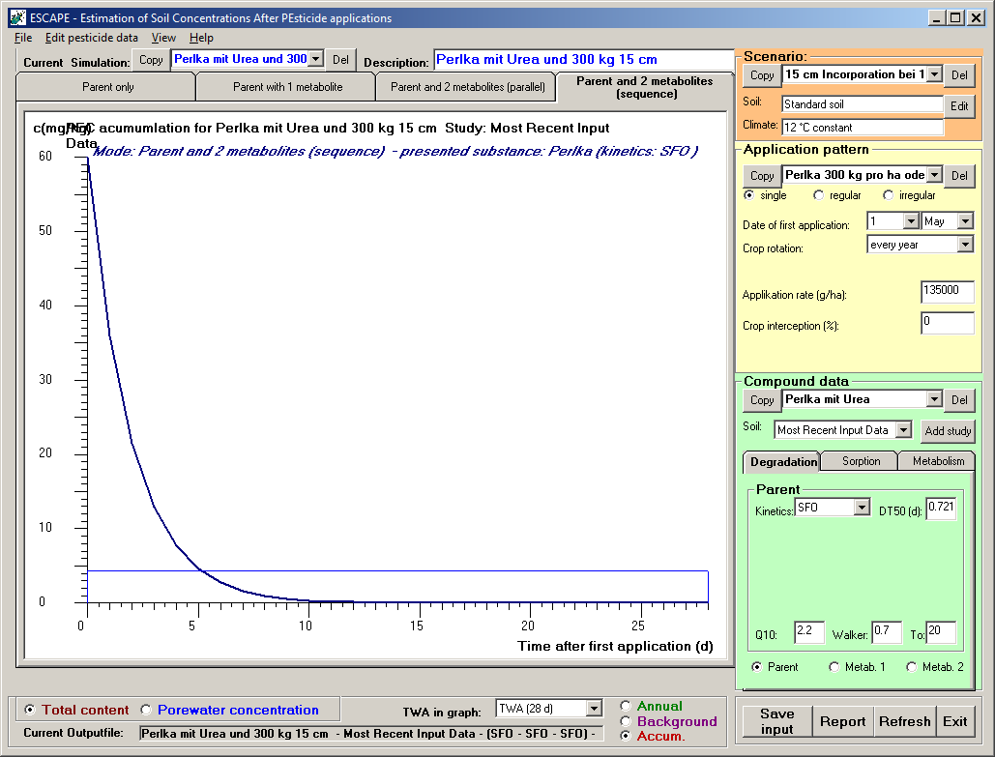

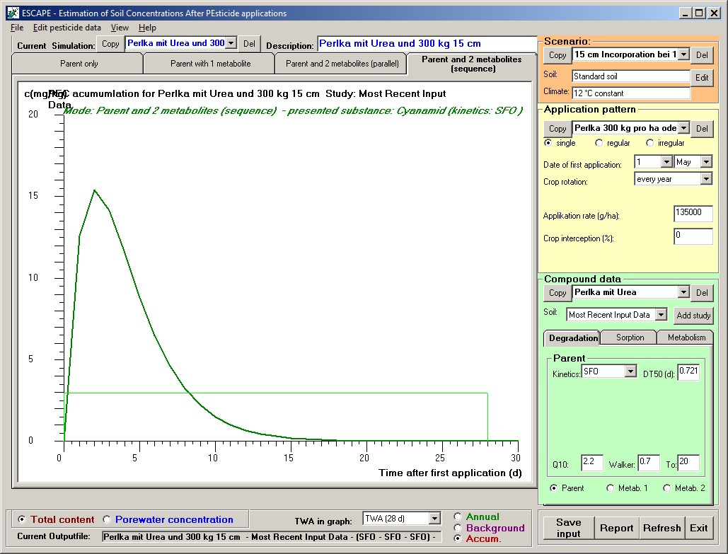

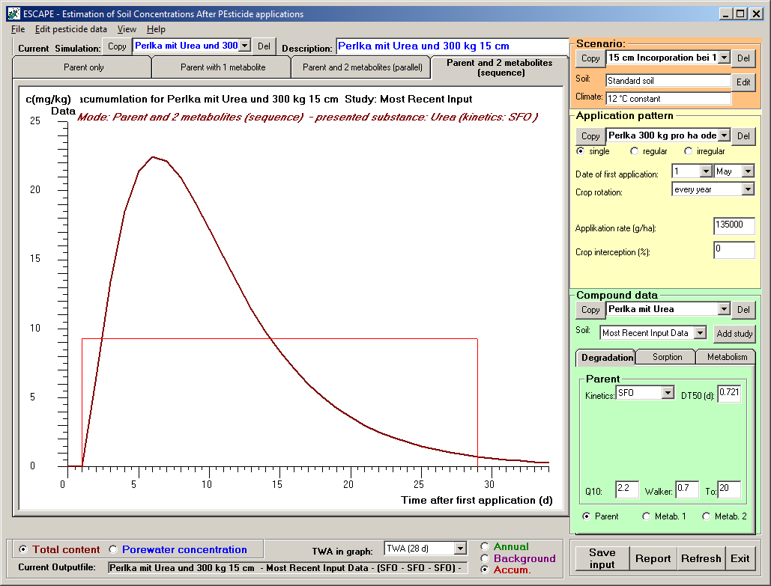

***E S C A P E***

**Estimation of Soil Concentrations After PEsticide Applications**

*developed by Michael Klein*

Program version: 2.0 (21 September 2018)

Date of this simulation: 20/11/2019, 13:40:42

Calculation problem: Perlka mit DCD und 300 kg 15 cm

PROGRAM SETTINGS

Calculation mode: Residues from different applications are considered separately over one year

Application mode: Single annual application pattern (calculation period 1 year)

SCENARIO DATA USED IN THE CALCULATION

Name of the scenario: Perlka 300 kg pro ha oder 135 kg CaCN2

Name of the soil: Standard soil

Soil density (kg/L): 1.5

Soil depth (cm): 15

Tillage depth (cm)*: 20

Organic carbon content (%): 1.5

Field capacity (Vol%): 29.2

Wilting point (Vol%): 6.4

Climatic conditions: 12 °C constant

(* for calculation of background concentrations)

APPLICATION PATTERN USED IN THE CALCULATION

Crop rotation: every year

Application date: 1 May

Application rate (g/ha): 135000

Crop interception (%): 0

COMPOUNDS CONSIDERED IN THE CALCULATION

Metabolism scheme: Active compound and a sequence of two metabolites

Compound Molecular mass(g/mol) Formation (%)

Perlka 80.11

Cyanamid 42.04 4 100

DCD 42.04 5.25 4.25

DEGRADATION KINETICS PARAMETERS CONSIDERED FOR THE CALCULATION

Soil study: Most Recent Input Data

Metabolism scheme: Active compound and a sequence of two metabolites

Kinetics for Perlka: Single First order (SFO)

DT50 (d): 0.721

Rate constant (1/d): 0.9614

Q10-factor: 2.2

Walker-exponent: 0.7

Ref. temperature (°C): 20

Kinetics for Cyanamid: Single First order (SFO)

DT50 (d): 0.78

Rate constant (1/d): 0.8887

Q10-factor: 2.2

Walker-exponent: 0.0

Ref. temperature (°C): 20

Kinetics for DCD: Single First order (SFO)

DT50 (d): 11.1

Rate constant (1/d): 0.0624

Q10-factor: 2.2

Walker-exponent: 0.7

Ref. temperature (°C): 20

**RESULTS OF THE CALCULATION**

Metabolism scheme: Active compound and a sequence of two metabolites

***RESULTS FOR: Perlka***

Calculations over one year

Maximum annual total soil concentration for Perlka over 15 cm(mg/kg): 60.0000 occurring on day 0

Calculated time dependent total soil concentrations over 15 cm for Perlka after one year (mg/kg)

Time(d) PECact* PECtwa Begin TWAframe(d) End TWAframe(d)

1 35.9712 47.9856 0 1

2 21.5655 38.3770 0 2

4 7.7512 26.0853 0 4

7 1.6702 16.6407 0 7

14 0.0465 8.5520 0 14

21 0.0013 5.7056 0 21

28 <0.0001 4.2793 0 28

42 <0.0001 2.8529 0 42

50 <0.0001 2.3964 0 50

100 <0.0001 1.1982 0 100

(* PECact values are related to the time after the first application)

*Calculation of background concentrations after many years*

Final Background concentration in total soil for Perlka over 20 cm(mg/kg): <0.0001**

(** according to the estimation 100% of the final plateau was reached after 10 years without crop rotation)

Reduction factor to account for crop rotation: 1

Final Background concentration in total soil including crop rotation(mg/kg): <0.0001

*Calculations of concentrations considering accumulation after many years of application*

Maximum total soil concentration for Perlka over 15 cm considering accumulation* (mg/kg) 60.0000

(* a tillage depth of 20 cm was considered for calculating the background concentration)

Calculated time dependent total soil concentrations over 15 cm for Perlka(mg/kg) considering accumulation*

Time(d) PECact** PECtwa Begin TWAframe(d) End TWAframe(d)

1 35.9712 47.9856 0 1

2 21.5655 38.3770 0 2

4 7.7512 26.0853 0 4

7 1.6702 16.6407 0 7

14 0.0465 8.5520 0 14

21 0.0013 5.7056 0 21

28 <0.0001 4.2793 0 28

42 <0.0001 2.8529 0 42

50 <0.0001 2.3964 0 50

100 <0.0001 1.1982 0 100

(* a tillage depth of 20 cm was considered for calculating the background concentration)

(** PECact values are related to the time after the first application)

**RESULTS FOR: Cyanamid**

*Calculations over one year*

Maximum annual total soil concentration for Cyanamid over 15 cm(mg/kg): 15.4179 occurring on day 2^

(^ This is 36.72 % of the theoretical maximum concentration of the metabolite)

Calculated time dependent total soil concentrations over 15 cm for Cyanamid after one year (mg/kg)

Time(d) PECact* PECtwa Begin TWAframe(d) End TWAframe(d)

1 14.1404 14.7792 2 3

2 11.5291 14.3965 1 3

4 6.4691 12.9498 1 5

7 2.2222 10.1841 0 7

14 0.1273 5.9181 0 14

21 0.0059 3.9774 0 21

28 0.0003 2.9842 0 28

42 <0.0001 1.9895 0 42

50 <0.0001 1.6712 0 50

100 <0.0001 0.8356 0 100

(* PECact values are related to the time after the maximum concentration)

*Calculation of background concentrations after many years*

Final Background concentration in total soil for Cyanamid over 20 cm(mg/kg): <0.0001**

(** according to the estimation 100% of the final plateau was reached after 10 years without crop rotation)

Reduction factor to account for crop rotation: 1

Final Background concentration in total soil including crop rotation(mg/kg): <0.0001

*Calculations of concentrations considering accumulation after many years of application*

Maximum total soil concentration for Cyanamid over 15 cm considering accumulation* (mg/kg) 15.4179

(* a tillage depth of 20 cm was considered for calculating the background concentration)

Calculated time dependent total soil concentrations over 15 cm for Cyanamid(mg/kg) considering accumulation*

Time(d) PECact** PECtwa Begin TWAframe(d) End TWAframe(d)

1 14.1404 14.7792 2 3

2 11.5291 14.3965 1 3

4 6.4691 12.9498 1 5

7 2.2222 10.1841 0 7

14 0.1273 5.9181 0 14

21 0.0059 3.9774 0 21

28 0.0003 2.9842 0 28

42 <0.0001 1.9895 0 42

50 <0.0001 1.6712 0 50

100 <0.0001 0.8356 0 100

(* a tillage depth of 20 cm was considered for calculating the background concentration)

(** PECact values are related to the time after the maximum concentration)'

**RESULTS FOR: DCD**

*Calculations over one year*

Maximum annual total soil concentration for DCD over 15 cm(mg/kg): 0.9449 occurring on day 8^

(^ This is 2.25 % of the theoretical maximum concentration of the metabolite)

Calculated time dependent total soil concentrations over 15 cm for DCD after one year (mg/kg)

Time(d) PECact* PECtwa Begin TWAframe(d) End TWAframe(d)

1 0.9394 0.9421 8 9

2 0.9181 0.9391 7 9

4 0.8493 0.9273 7 11

7 0.7254 0.9013 5 12

14 0.4750 0.8127 4 18

21 0.3071 0.7126 3 24

28 0.1983 0.6208 2 30

42 0.0827 0.4780 2 44

50 0.0502 0.4172 1 51

100 0.0022 0.2205 1 101

(* PECact values are related to the time after the maximum concentration)

*Calculation of background concentrations after many years*

Final Background concentration in total soil for DCD over 20 cm(mg/kg): <0.0001**

(** according to the estimation 100% of the final plateau was reached after 10 years without crop rotation)

Reduction factor to account for crop rotation: 1

Final Background concentration in total soil including crop rotation(mg/kg): <0.0001

*Calculations of concentrations considering accumulation after many years of application*

Maximum total soil concentration for DCD over 15 cm considering accumulation* (mg/kg) 0.9449

(* a tillage depth of 20 cm was considered for calculating the background concentration)

Calculated time dependent total soil concentrations over 15 cm for DCD(mg/kg) considering accumulation*

Time(d) PECact** PECtwa Begin TWAframe(d) End TWAframe(d)

1 0.9394 0.9421 8 9

2 0.9181 0.9391 7 9

4 0.8493 0.9273 7 11

7 0.7254 0.9013 5 12

14 0.4750 0.8127 4 18

21 0.3071 0.7126 3 24

28 0.1983 0.6208 2 30

42 0.0827 0.4780 2 44

50 0.0502 0.4172 1 51

100 0.0022 0.2205 1 101

(* a tillage depth of 20 cm was considered for calculating the background concentration)

(** PECact values are related to the time after the maximum concentration)'

GRAPHIC REPRESENTATION OF THE CALCULATION

